**Lab – 52: Working with the ATA Health Center.**

**Objective:** The objective of this lab is –

* To work with the ATA Health Center.

The ATA Health Center lets you know how your ATA service is performing and alerts you to problems. In this lab, we are going to work with the ATA Health Center and check for the activities.

**Prerequisite:** Windows Server 2016. Windows server should be a member of a domain or workgroup. At least one network adapter. Microsoft .Net Framework 4.6.1 or later. Browser - Internet Explorer version 10 and above (or any other latest browser).

**Steps:**

1. Open Microsoft ATA Console and login with your credentials. The ATA Health Center lets you know that there's a problem by raising an alert **(a red dot)** above the Health Center icon in the menu bar.
2. To check up on your system's overall health, click the **Health Center** icon in the menu bar (**red dot**).



1. **Open**: All new suspicious activities appear in this list. The activities are categorized according to its severity level (**High, Medium or Low**).

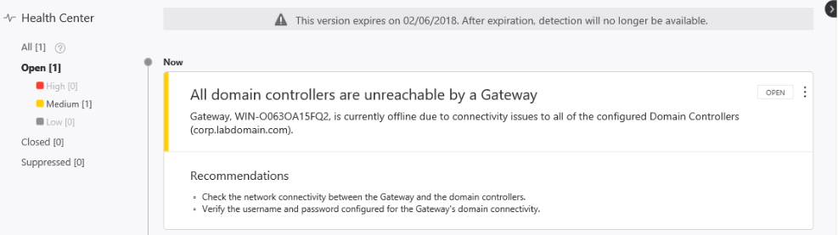

1. Click **All** to track all suspicious activities.

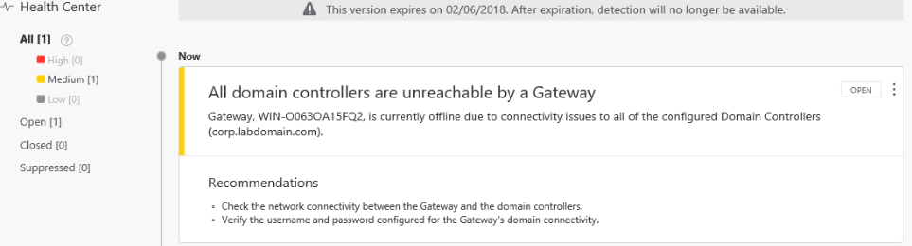

1. **Closed:** Is used to track suspicious activities that you identified, researched, and fixed for mitigated.
2. **Suppress:** Suppressing an activity means you want to ignore it for now, and only be alerted again if there's a new instance. If there's a similar alert ATA doesn't reopen it. But if the alert stops for seven days, and is then seen again, you are alerted again.
3. All open alerts can be managed by setting them to **Close** or **Suppress** by clicking the three dots in the corner of the alert and making your selection. If you click close, you will be alerted if the same activity will recur. And, if you click Suppress, it will ignore the activity this time but you will be alerted if it resumes after a day.

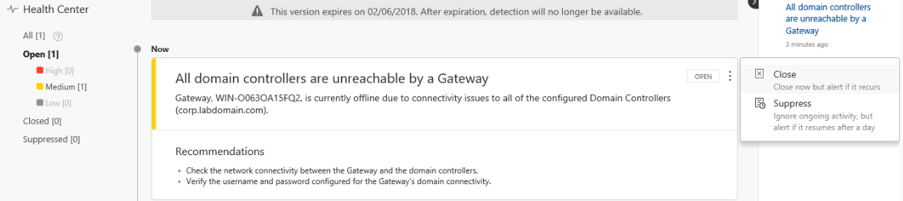

1. So, in this way you can work with the ATA Health Center and check all the suspicious activities in your ATA Console.